Appendix No. 8
to the contract of participation in the exhibition «ParkZoo 2024» № of « » «___________» 20__

APPLICATION FOR EQUIPPING STANDARD STANDS ACCORDING TO THE IMPROVED STANDARD SYSTEM
Exhibitor___________________________Responsible person ______________________________
IMPROVED STANDARD No. 11
The total height of the stand structures is 5 m; the height of the walls is 2.5 m; constructive – Mero R8, Mero R8+
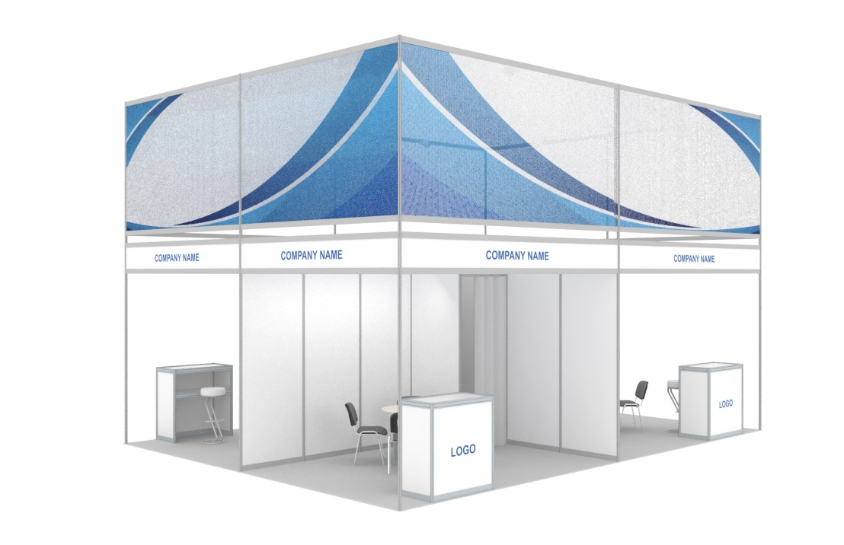

EQUIPMENT | 9-12 м² | 13-24 м² | 25-36 м² | 37-48 м² | 49-60 м²
Carpeting | V | V | V | V | V
Perimeter walls | V | V | V | V | V
Front construction (Mero R8+, H = 5 m), with banner grid (H = 1.9 m) | V | V | V | V | V
The frieze panel is inset with an inscription, on the open sides of the stand | 2 | 2 | 2 | 4 | 4
Utility room with sliding door, 1 m2 | 1 | 2 | 2 | 3 | 4
Information desk with a color logo (1x1 m), code 318 | 1 | 1 | 1 | 2 | 2
Bar stool (code 306) | 1 | 1 | 1 | 2 | 2
Round table (code 314) | 1 | 1 | 2 | 2 | 3
Meeting chair (code 303) | 3 | 4 | 6 | 8 | 12
Metal halide spotlight, 150 W (code 514) / LED analog | 3 | 4 | 5 | 6 | 8
220V socket, up to 1 kW (code 505a) | 1 | 2 | 3 | 4 | 5
Cantilever hanger (code 331) | 1 | 1 | 2 | 2 | 3
Trash can (code 377) | 1 | 2 | 2 | 3 | 3

Note: all sizes are indicated approximately,
the exact figures should be checked with the manager.

Information provided by the Exhibitor:
- carpet color (according to the ExpoRadu layout);
- logo (vector format);
- banner grid layout (format – vector or TIFF; resolution – not less than 300 dpi; size – on request);
- text of the inscription (color according to the layout of Oracal 641).

The cost of an additional payment for 1 sq. m is
6,530 RUB/101 EURO/109 USD/653 CNY

IMPROVED STANDARD No. 14
The total height of the stand structures is 3.5 m; the height of the walls is 2.5 m; constructive – Mero R8, Mero R8+
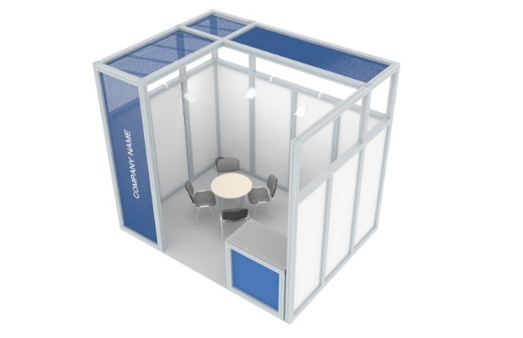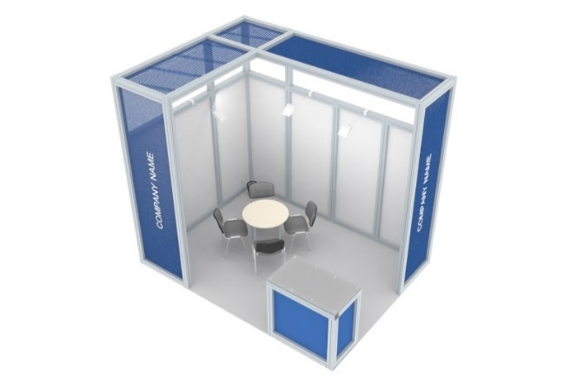

EQUIPMENT | 9-12 м² | 13-24 м² | 25-36 м² | 37-48 м² |  | 49-60 м²
Carpeting | V | V | V | V |  | V
Perimeter walls | V | V | V | V |  | V
Front and ceiling structures (Mero R8+, H = 3.5 m) | V | V | V | V |  | V
Banner grid with horizontal printing (width – 900 mm) | 2 | 2 | 2 | 2 |  | 2
Banner grid with printing vertical (3.3x0.9 m) on the open sides of the stand | V | V | V | V |  | V
Information desk | 1 | 1 | 1 | 2 |  | 2
Round table (code 314) | 1 | 1 | 2 | 2 |  | 3
Meeting chair (code 303) | 3 | 4 | 6 | 8 |  | 12
Spot-sconce lamp, 75 W (code 510) / LED analog or halogen spotlight on a rod, 150 W (code 516) | 3 | 5 | 6 | 7 |  | 8
Triple 220V socket, up to 1 kW (code 505a) | 1 | 1 | 1 | 2 |  | 2
Trash can (code 377) | 1 | 1 | 1 | 2 |  | 2

Note: all sizes are indicated approximately,
the exact figures should be checked with the manager.

Information provided by the Exhibitor:
- carpet color (according to the ExpoRadu layout);
- layout of a vertical banner grid (format – vector or TIFF; resolution – not less than 300 dpi; size – 3300x900 mm);
- layouts of horizontal banner grids (format – vector or TIFF; resolution – not less than 300 dpi; size – by request);

The cost of an additional payment for 1 sq. m is
4,420 RUB/68 EURO/74 USD/442 CNY

IMPROVED STANDARD No. 19
The total height of the stand structures is 3.6 m; the height of the walls is 3.6 m; the structural element is Mero R8
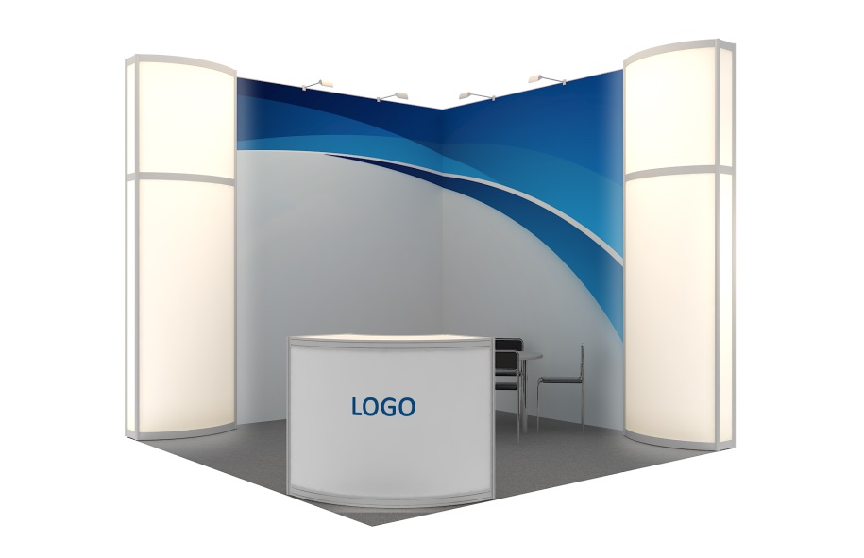 | 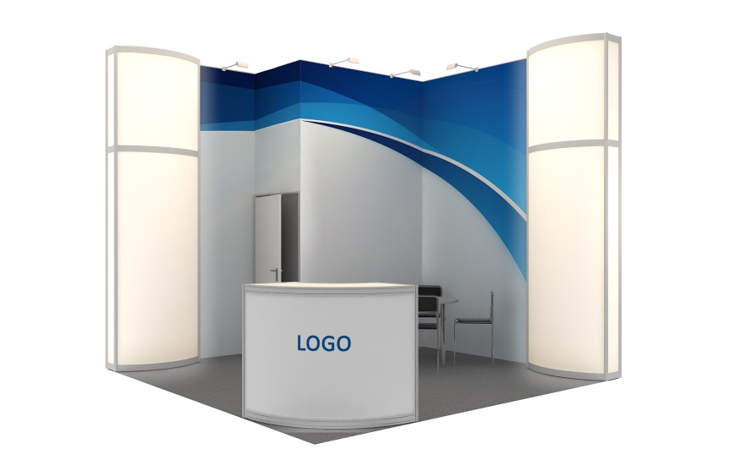
EQUIPMENT |  | 9-12 м² | 13-24 м² | 25-36 м² | 37-48 м² | 49-60 м²
Carpeting |  | V | V | V | V | V
Perimeter walls (H = 3.6 m) |  | V | V | V | V | V
Light column (3.6x1x0.25 m, filling — "milk" plexiglass) with internal illumination and logo (0.4x1 m), at the corners of the stand on the open sides |  | V | V | V | V | V
Banner (H = 3.6 m) on the walls (installation on mortgages) |  | V | V | V | V | V
Utility room with swing door, 1 m2 |  | V | V | V | V | V
Information desk (R=0.5xR=1 m, H = 1.1 m), with a color logo (1x1 m), code 709 |  | 1 | 1 | 1 | 2 | 2
Bar stool (code 306) |  | 1 | 1 | 1 | 2 | 2
Round table (code 314) |  | 1 | 1 | 2 | 2 | 3
Meeting chair (code 303) |  | 3 | 4 | 6 | 8 | 12
Halogen spotlight on a rod, 150 W (code 516) |  | 3 | 5 | 6 | 7 | 8
220V socket, up to 1 kW (code 505a) |  | 1 | 2 | 3 | 4 | 5
Cantilever hanger (code 331) |  | 1 | 1 | 2 | 2 | 3
Trash can (code 377) |  | 1 | 2 | 2 | 3 | 3

Note: all sizes are indicated approximately,
the exact figures should be checked with the manager.

Information provided by the Exhibitor:
- carpet color (according to the ExpoRadu layout);
- banner layouts (format – vector or TIFF; resolution – not less than 300 dpi; size – on request);
- logos on light columns and information stand (vector format).

The cost of an additional payment for 1 sq. m is
13 552 RUB/209 EURO/226 USD/1355 CNY

_______________________________: _______________________ _______________________
signature Name
Stamp
« »____________20_____

* All services rendered are not subject to VAT.

